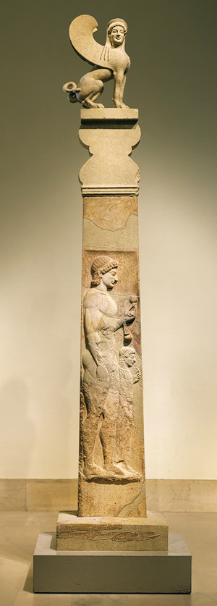
Daniel 3

3:1
The statue probably stood on a tall base to reach the height of 90 feet
Image is a grave stele from 530 BC
It was probably not an image of Nebuchadnezzar since this type of worship was uncommon. It may have been more likely an image of Nebo.

Dura means "walled place" or "fortification". Many places included this word since many places would have been "walled". The best guess is six miles south east of Babyulon

3:2
There is an "and" before "governors" indicating that Satraps, Prefects and Governors were the senior officials over the others.
- Satraps - Persian word for ruler of a province
- Prefects - ( princes) were military chiefs
- Governors -(captains) heads of sections in the provinces
- Advisers - (counselors, judges) high ranked jukdges
- Treasurers- overseers of the national treasurery
- Judges - (counselors) were secondary level judges
- Magistrates - (sheriffs) were lower level legal officials
- Provincial Officials - subordinates under the Satraps

3:4
Different nationalities were represented in Nebuchadnezzar's leadership team.

3:5
English translations indicate uncertainty concerning these instruments. This seems to be sure:
- horn - wind instrument
- flute - wind instrument
- zither - stringed (a type of harp) (a Greek word)
- lyre - stringed
- harp - stringed (a Greek word)
- pipes - ??? may be an instrument or an ensemble; maybe a tambour or tambourine (a Greek word)
- all kinds of music

Note Psalm 137 and Isaiah 14:11

3:6
Blazing furnace would be on site and used for melting and casting metal to plate the image. The furnace would also have been used for manufacturing the bricks.
Most likely it had an opening at the top for insertion of the ore to be smelted. This is where the men were thrown in. At the ground level there would have been a door on the side to insert wood and charcoal. This is where Nebuchadnezzar looked into the fire. It was not designed for punishment. The kilns at this time operated at 900 degrees centigrade. They maxed out at 1,000 centigrade or 1800 fahrenheit. This was the normal operating temperature. Technology at this time would not have allowed the furnace to actually be heated up 7 times more or 6,300 degrees centigrade.

Jeremiah 29:22 records Nebuchadnezzar burning to death Zedekiah and Ahab. They were false prophets in Babylon at this time.

3:8
The informants were astrologers. These would be individuals who had been overlooked with these three Jewish men's promotion.

"denounced" is literally "ate the pieces of" or, in English "chewed them out."

3:12
attack on the king's judgment
attack on the Jewish faith and religion

Three charges:
- Pay no attention to the king
- Do not serve your gods
- Do not worship the image of gold

3:13
"furious with rage" is "regaz" = "in fury" and "hama" = "in rage"
Combined they mean "extreme anger"

3:15
Their God had proven he could interpret dreams, but he surely could not save from the fire

3:16
No defense is given. No apologetic proof provide. Just the results of this encounter:
- God will deliver
- Shadrach, Meshach and Abednego will die as martyrs

3:23
"fell into" is literally "fell down to the middle of"

3:25
Isaiah 43:2
Hebrews 11:34

"son of the gods" is a common expression at the time to refer to a supernatural being. This would be a perfect term to refer to one of the gods in the Babylonian pantheon.

