Idol Worship

I remember being in Sunday school through out my childhood and my teenage years. Back in the “old days” churches would give out Sunday school pins to children if they had good attendance. I think we could miss three Sundays a year and still get a pin. I still have my Sunday school pins from each year beginning in 1963 when I was a 3 year old Presbyterian up until I was a Methodist teenager in 1975. I remember quite a few things from Sunday school during those years. I remember my mom teaching some of my younger classes and my dad teaching a junior high class one year. I remember the opening songs and the hand motions. I remember the Sunday school books, Christmas programs and putting coins in the plastic church to make the bulb in the steeple light up once a year on our birthdays. I also recall being extremely bored, making the other kids laugh during class, writing on the Sunday school tables and wondering why anyone could care about these confusing, pointless stories in the Bible. I can still feel the sense of escape and the rush of freedom when the church doors would finally open after the service and we could run out into the church yard to play where the air was fresh and the sun was bright. The parents would linger inside talking and always drinking coffee.

We learned the stories of the Bible. I think I heard just about every story in the gospels and all the OT stories that had any strange twist or great action. I particularly remember Jezebel getting pushed out of the window and eaten by dogs. I don’t remember the point of the lesson, I just remember the story.

One thing I remember learning about over and over again was the evil of idol worship. This always seemed to prove to me that Sunday school was just a formality and a ritual. Why I had to get up on a Sunday morning to be told not to worship idols was beyond my realm of understanding and field of experience. First, I had never seen an idol. Second, I would wonder, how do you worship an idol just in case I might some day possibly located one and hide it in my room back home? Third, I would look around the room, as the lesson dragged on, and try and picture who in this room is actually struggling with the temptation to worship idols? No one! Then the lesson would come to the point where we would be told that anything could be an idol like money, or sports, or a girl friend. (The girl friend “idol” I always thought would be a good problem.) This would only cause me to wonder what kind of people lived in the Bible times. Didn’t they have money, sports or girls? I knew they did, so why would they resort to making a stone or a gold statue.

This and many other questions would remain. I often thought about them but they would always circle back to the unanswered, illogical conclusion. Soon I moved up into the Sunday school classes that did not receive attendance pins any more nor did they rush for the light of an open door after church. These are those that had grown up comfortable in the church. But, myself, I never liked coffee. I think coffee, like organ music, reminds of Sunday mornings with the doors closed. Spiritually I could stay there no longer and at the age of 23 I made a break for the door.

It was at that point I began to realize that questions need to be asked over and over and over until you not only have an answer but you also understand the answer. The difference between knowing the answer and understanding the answer is the difference between being incapable and being able to function. It is what separates doubt from faith. Knowing an answer to a math problem is easily memorized: 7 x 7 = 49. Memorize that answer! But, if you do not understand it you are back to a state of ignorance if you change the problem to 7 x 8 = ____ or 6 x 7 = ____. Some one who understands the answer to 7 x 7 will be able to figure out the other two. Someone who simply knows the 7 x 7 = 49 because some one told them and they memorized it is paralyzed when the problem changes slightly. So it is with the truth of scripture. Never simply accept the answer. Understand it! This is not a study skill for the faint hearted, though. The Sunday school coffee drinkers don’t consider this a virtue. They don’t like it one bit. Some will ask, “Why can’t you be satisfied with 7 x 7 = 49? Why do you question it. Don’t you believe.” I must question it because, even though I know the answer, I do not understand it. People who seek understanding seem to come across in a very bad way to those who know the answer. And one more point, the time it takes between hearing the answer and understanding the answer is a lot longer and more difficult than many of us are willing to wait. You will often have to say, “I do not understand” in the midst of those who are content to simply know the answer. It is perceived as arrogance but it is the humility of self before the honor of truth.

For years I knew the answer that modern idol worship was money, power, fame, or anything that comes before God. Who is going to argue with that application. No one, and not me. But, I still have to ask the same thing I did as a 12 year Sunday school student over 30 years ago. Why the stone images? Why don’t we have them today? The people of Israel where not told stop worshiping money, self, chariots, etc. God clearly spoke against these stone images. They even had names. Yes, and these idols, or false gods, had a story. The story included the history of the god which revealed the character of the god which would communicate the god’s values, morals and standards of living. These little stone statues came with all the accessories. They included a philosophy and a world view that a true worshipper would use to make decisions and live their life by. Yes, indeed, many of the worshippers ended up in materialism but materialism was the result of the philosophy coming from thier false gods and not idol worship itself.

God or a god does these things for a people:
- Explain Origins
- Identify Purpose
- Develop Ethics
- Determine Future

The quick “answer” to these four points when applied to the LORD God are:

He created us and our universe to serve him in time as a people who are holy like he is holy and then spend eternity in his presence forever and ever.

Obviously, this could be developed and expanded on. For those of you who are not satisfied with my above “answer” and would refer to it as a “cliché” I sympathize with you because your desire is to understand. You have my respect, but not my time right now. I am moving on.

To determine where the culture of the United States is at in regard to idol worship we have to answer these four questions. We are a secular culture with a Christian heritage so our answers will reveal the results of a century long philosophical tug of war. In a tug of war with two fairly evenly matched teams you will see a lot of effort and straining. Both sides pull to the point of exhaustion but the results show very little movement or progress. Not until one side wears the other side down do you see progress. Then the victory goes to the side with the greatest endurance. We are fortunate to be living at this time in our society. I believe the 80 year tug of war between people who believe there is a God and the secular humanist is showing signs of exhaustion on the side of the secular humanist. This may describe for us our current state. Our culture has been worn down by the secular humanistic views. Many have grown weary and given up the struggle against them, but the same is true on both sides of the rope. The spiritual reality of God and his eternal truth has become more and more evident during this struggle. With that in mind the results of the last 80 years should not surprise us. The religion of man has pulled long and hard on the soul of society with doubt, unbelief and skepticism. But, the religion of truth and reality under God the creator is not going to go away. It can not because it is reality. In fact, the truth of God is the reality where in doubt and skepticism find their own existence. Without truth and reality there would be no logic and without logic there would be no platform by which to present an argument of skepticism. It would be like running in air or a better illustration – it would be like a tug of war with no one pulling on the other side. There would be no such thing as a tug of war. The same is true with doubt and skepticism. Before doubt can even exist there must be truth and reality. I, as one who believes in the existence of truth and reality have no trouble believing there is doubt and skepticism. Why can’t humanism, which argues doubt and skepticism, realize that their opposition, which is truth and reality, also exists? Why do those who preach there are no absolutes, there is no God, there is no purpose realize those views are not a platform in themselves but by their own definitions are simply a claim that something else does not exist. No wonder Americans still believe in God. Why should we be surprised?

(A definition of “secular” from Webster’s is “of or pertaining to the worldly or temporal as distinguished from the spiritual or eternal.” A secularist is defined as “one who rejects every form of religious faith and worship, and undertakes to live accordingly.” )

How does the United States culture explain human origin?
With all the talk and teaching on evolution you would expect the answer to be that man evolved from lower life forms usually out of the sea. If we check the polls of the American people over the last 25 years we will find that our culture is holding a firm grip on God considering all the effort that goes into promoting evolution in public schools and higher education. A gallop poll from Feb. 2001 produced these results:

“45% of respondents chose "God created human beings pretty much in their present form at one time within the last 10,000 years or so," the statement that most closely describes biblical creationism.

“A slightly larger percentage, almost half, chose one of the two evolution-oriented statements: 37% selected "Human beings have developed over millions of years from less advanced forms of life, but God guided this process"

“and 12% chose "Human beings have developed over millions of years from less advanced forms of life, but God had no part in this process."

“The public has not notably changed its opinion on this question since Gallup started asking it in 1982.”

From - http://www.unl.edu/rhames/courses/current/creation/evol-poll.htm
On December 14, 2006

Evolutionist bemoan the fear that we are headed back into the dark ages because public opinion does not support evolution, in fact, public opinion supports creation as is seen in this 2005 poll:

“A recent survey by the Pew Forum on Religion and Science found that 64 percent of respondents support teaching creationism side by side with evolution in the science curriculum of public schools. A near majority—48 percent—do not believe that Darwin’s theory of evolution is proven by fossil discoveries. Thirty-three percent believe that a general agreement does not exist among scientists that humans evolved over time.”

The Pew Research Center for the People and the Press: Reading the polls on evolution and creationism, Pew Center Pollwatch. September 28, 2005. Available at: http://people- press.org/commentary/display.php3?AnalysisID=118. Accessed November 21, 2005.

An online article by Eric Blievernicht says:

“According to a 1993 Gallup poll, 47% of the American public adopted the young earth creationist view that humans were created by God around 10,000 years ago. Another 35% were theistic evolutionists, and only 11% believe the universe has evolved naturally. This makes evolutionists who try to portray young-earth creationists as a small fringe group look a bit silly.
Especially when you realize that young-earth creationism is actually growing: a similar Gallup poll in 1982 showed only 44% believed in a young, created earth. Since scientific creationism only dates to the early 1960's, belief in a special creation was probably even less prevalent prior to 1982.
These facts conflict rather badly with the popular myth of evolutionists that creationists are "behind the times" or "throwbacks." Indeed, in a recent debate a non-creationist historian acknowledged that belief in a young, created earth was more prevalent now among Christians than any time since at least 1830.
Another important fact to consider is that this surge in belief in divine creation is not based on religious beliefs so much advances in science. In fact, polls and informal studies suggest that the percentage of scientists who believe in a young, created earth is at least as high and probably higher than the percentage of theologians who believe the same! Certainly, a majority of Christian scientists now accept Genesis literally; yet one informal poll indicated that only around 10% of so-called Christian theologians teach a literal Genesis! We are now literally in a position where scientists are trying to get the theologians to stop compromising and butchering God's Word because of "scientific" objections that have been largely overcome.”

From - http://www.rae.org/polls.html on December 14, 2006

Our culture has two answers to the question of origin and each answer represents a philosophy and world view of its God. There are those who believe we came from God by the process of creation (47%) Then there are the secularists who believe that man’s origins are from evolution with no God assisting.(11%) I believe the days of the atheistic evolutionist are slipping away. We are heading into a world of the future that is going to be very religious, not necessarily Christian, but a world that believes in God. We have known for years that the world was not going to end in the hands of the secular humanist because in the final days before Christ returns the Bible reveals that the world is not filled with atheist but with people who believe in a god. The world as we know it will end with such a religious fervor that they will actually crown a man as god:

“He will oppose and will exalt himself over everything that is called God or is worshiped, so that he sets himself up in God’s temple, proclaiming himself to be God.”
(2 Thessalonians 2:4)

“All inhabitants of the earth will worship the beast. . ..He was given power to give breath to the image of the first beast so that it could speak and cause all who refused to worship the image to be killed.” (Revelation 13:8, 15)

We need to continue to communicate the truth of God as the creator, but realize that scientific study will continue to uncover the creator. Science will never find the missing links, let alone, connect them.

Our next concern now is the religious move that is now developing and will come to undermine the truth. It will not be science that undermines the LORD because “God’s invisible qualities . . . have been clearly seen, being understood from what has been made.” (Romans 1:20) What is on the horizon is a new awakening to the spiritual dimension. The pendulum of error is swinging from denying the existence of God to embracing the spiritual concept of God. The challenging part of this that will prove to be the most dangerous and damaging if we fail is to keep this awakening in the truth and in God’s reality. I think our next enemy is more than man, more than humanism, and more than denying the existence of God. Our next enemy will be spiritual, demonic and will claim to be the true God.

While 91.8% of the people in the United States believe in the existence of a God according to a Gallup Poll written and analyzed by Baylor University and reported in September 12, 2006 USA TODAY only 11% say the American society very closely reflects Christianity as reported by Newsweek Dec. 5, 2004. Forty-four percent of Americans believe the second coming of Jesus to the earth will occur in the next 50 years and almost half of the population in the United States are anticipating the end of the world. (November 13, 2006, Newsweek, by Sam Harris from
http://www.msnbc.msn.com/id/15566391/site/newsweek/)
From what we see in statistics and in the lives of people in the United States of America our problem is not that we do not believe in God but that we do not live like we believe in God.

Percentage of Americans Who Believe These Statements (Newsweek 12/10/04)
82% Believe that Jesus lived
55% Believe that every word of the Bible is literally true
79% Believe that Jesus was born of a virgin
67% Believe the details of the Christmas story are true
52% Believe that Jesus will return to earth
63% Believe there would be less charity if Jesus had not lived
61% Believe there would be less kindness if Jesus had not live
59% Believe there would be less personal happiness if Jesus had not lived
58% Believe there would be less tolerance if Jesus had not lived
62% Believe creation should be taught in schools
Dec. 5, 2004, Newsweek, (updated dec. 10, 2006) A Newsweek Poll http://www.msnbc.msn.com/id/6650997/site/newsweek/

What the secular humanist movement tried to accomplish over the last 80 years has damaged the soul of the United States but has not conquered it. Our culture has fought the battle against doubt and unbelief. We have suffered spiritual casualties, but we see this secular enemy retreating back into the twentieth century as the Christian faith moves on to face an even more threatening adversary. We have been weakened as a culture but we have not lost our culture. We must take the victories of faith and the victories of morality that we have won and prepare our souls for the battle in our generation that will determine if the United States has another generation.

Idol Worship in the United States

Now to answer the questions of idol worship in the United States. Although we still believe in “one nation under God” our soul has been damaged by secular humanism. The vast majority of Americans have come through the public school system. Since the days of John Dewey, who signed the Humanist Manifesto in 1933 and became the father of our modern school systems, every one of us have been educated in a humanistic system. I am still amazed that after all these years and all this humanistic education and philosophy from the years 5-18 that 91.8% of us believe in the existence of a God, 82% of us still believe Jesus lived, and 55% of us accept the Bible to be literally true. (I wonder if 55% of our nation’s church leaders and administrators even believe that last one? Revival must come in spite of church leaders.) The secular humanist have instilled into the souls of Americans a dangerous philosophy. The answers to these questions will reveal that this secular humanism is the idol of the United States and the answers to these questions will show us where we manifest our worship of this idol in our daily lives:

How does the United States culture explain human origin?
The Philosopohy of the Secular Humanist says: Evolution explains where we came from. We emerged from nothing. The odds of it happening are extremely impossible which means we are a freak of nature which it self is pointless.
How Does the United States Identify the Purpose for Life
The Philosopohy of the Secular Humanist says: If we are an oddity that emerged out of nothing from a pointless universe. There is obviously no plan or purpose for our lives. So we need to create purpose in this meaningless life. We as a culture have found meaning in our lives by pursuing materialism and pleasure.

How Does the United States Develop Ethics
The Philosopohy of the Secular Humanist says: The idea that everyone should just do what they feel is right could only last so long. Usually it worked until someone does something that someone else doesn’t like then we want rules, laws, ethics and a system of punishment. But, until then it is a great idea. Where do the humanists turn to determine right and wrong? We have a legal system in our country. This legal system votes and makes decisions on what is right and what is wrong. Of course, the legal system itself is voted into office by the people. This form of government is called democracy. The problem is that popular opinion rules a democracy. This is good if the people of the democracy are truly moral. If the majority are corrupt then their vote is corrupt. This results in a corrupt legal system which produces corrupt laws and standards. This could be even worse if we consider where popular opinion very often comes from. The media controls the vast part of popular opinion. If anyone question the power of the media just follow the money. Why do companies pay $2.5 million for a 30 second commercial on Super Bowl Sunday? Is it because they really believe in the importance of football in America and want to do their part to support its continuation? Or, is it because the media has such a great influence over our culture that they are willing to pay $73,333 to control one second of it?

How Does the United States Determine Future
The Philosopohy of the Secular Humanist says: The future of the United States is connected with the global vision of a world communal society living in peace. According to the humanist if we follow their doctrines we will usher in a world utopia. Below is theses number 14 of the original Humanist Manifesto I of 1933:

“The humanists are firmly convinced that existing acquisitive and profit-motivated society has shown itself to be inadequate and that a radical change in methods, controls, and motives must be instituted. A socialized and cooperative economic order must be established to the end that the equitable distribution of the means of life be possible. The goal of humanism is a free and universal society in which people voluntarily and intelligently cooperate for the common good. Humanists demand a shared life in a shared world.” (see full text of Humanist Manifesto I at the end)

Whenever you experience any of these things with out God’s truth and God’s reality you have entered into to the worship system of the idol of the United States. The idol is secular humanism and these are the ways we worship it in our daily lives within our society:
- Evolution
- Materialism
- Pleasure
- Legislature
- Democracy
- Popular Opinion
- Media
- World Peace

I must stress again what I just said. These things are the system by which the United States serves its idol which is the philosophy of secularism and humanism. Each of these things when used to serve the truth and reality of the Creator are good and sanctified for his worship.

1. Evolution involves the pursuit of scientific study and scientific study is good. Scientific investigation is what brought the world out of the dark ages. Every time an evolutionist discovers a truth in nature he has discovered information about what the Creator has made. Many former evolutionists now accept the idea of a Creator because they discovered Him in their studies. Countries around the world are dealing with the return of creationism. An article entitled “German Scientists Concerned About Rise in Creationist Belief” responds to education minister Karin Wolff’s comment that supported the teaching of creationism in schools. She said concerning teaching creationism, "I think it makes sense to bring up multidisciplinary and interdisciplinary problems for discussion.”
(Feb. 11, 2006, http://www.dw-world.de/dw/article/0,2144,2222454,00.html ) An article from Financial Times on October 14, 2006 says that because of the scientist who are now supporting intelligent design “a poll found that 44 per cent of the public - religious or secular - believe that creationism should be taught in UK school science lessons.” (http://www.ft.com/cms/s/aa7dcb90-5b20-11db-8f80-0000779e2340.html
The journal Nature (October 25, 2006) reports, Mirosaw Orzechowski, Poland's deputy education minister, told a newspaper, "The theory of evolution is a lie ... It is an error we have legalized as a common truth." (http://www.ncseweb.org/resources/news/2006/XX/961_creationism_news_from_around_t_11_2_2006.asp) Scientific investigation into evolution is good as long as both sides continue to pursue scientific facts with solid scientific methods. If there is a Creator he will have left his mark on his work. Honest evolutionist and creationist will see it.

2. Materialism is evil only because it has been separated from its Creator and his purpose. How can possessing material things be wrong in the ethics of someone who is a Creationist? If you claim to worship the Creator you should at least show some respect for what he created and honor it. The problem with material things within the idolatry of secular humanism is that material things have been separated from the creator. This leaves material things with no standard and no purpose. Instead of being honored they are lusted after for self-gratification with no regard for the purpose or Creator.

3. Pleasure is something man was created to be able to recognize, pursue and enjoy. We have all the features needed for pleasure in its varied forms. But within the realm of truth and reality of man’s purpose and his present condition life is much more meaningful than to be consumed in a lifelong pursuit of pleasure. In reference to a man who had encircled himself with pleasure and comfort but had no regard for God, Jesus quoted the man telling himself, “You have plenty of good things laid up for may years. Take life easy; eat, drink and be merry.’ Jesus called him a fool for God would demand his life from him and all his pleasures would prove useless. (Luke12:19, 20).

4. Legislature is the application of God’s fourth institution called government. God designed men to maintain law and order in their nations. God’s plan was that governments would be just and enforce what was right. Within the institution of government men have the responsibility to determine laws and regulations. In some cases the laws are made by men for men. For example speed limits, taxes, when a city turns the street lights on are examples of laws and regulations that have not been established by God before time began. Congressman can change them. In these areas we look for wisdom from our representatives. There are issues that God has established that can not be tampered with or voted on such as justice, honesty, life, and the pursuit of social order. When legislature begins to altar the standards that God has established for all men, in all cultures, in all times they indicate they have entered into idol worship of a false god.
5. Democracy is possibly the best form of government available to man but only if the individual men are just, honest and wise. If the subjects of the democracy are corrupt, selfish and fools then even a dictatorship would be better. The ultimate end of a democracy with immoral citizens is political corruption that results in anarchy that resorts to a military state before it collapses.

6. Popular Opinion is a good thing to be sensitive to. Solomon’s son, Rehoboam, rejected the voice of the public concerning taxation and lost the 5/6 of his father’s kingdom. In that case to reject public opinion was foolish. When popular opinion begins to establish what is right and wrong, violates absolute values or weakens the institutions that God has established it must be rejected for what it is – the voice of corrupt man.

7. Media is the voice of those who control the avenues of communication. May God help us because people are not called sheep by God because he thinks we are fluffy. God calls men sheep because sheep follow whoever is in front of them and even mimic their actions. If the first sheep jumps over a log the next sheep will jump over the log as will the next sheep. But, if the log is moved to clear the way for the next sheep he will not notice that the log is gone because his brain is too small to analyze the situation and finds it good enough to jump over nothing than to think. This then continues as the following sheep also jump when the get to the spot where the log used to be. Likewise, men are designed to imitate and follow leadership. (This is one reason why raising children is even a possibility.) To intelligently analyze situations for ourselves and not merely jump because everyone else jumped is an unnatural discipline that men must develop.

8. World Peace will be the result of Jesus’ return to the earth and even then only after he has won the peace through victory in history’s greatest battle. Before he returns any dissolving of the institutions that God has designed will end up in world war, poverty and mass injustice. Do not be fooled. The closest we can come to world peace is to uphold the institutions that God has given mankind: individual volition, marriage, family, government and nationalism.

Idol Worship and the Four Generation Cycle
In the Ten Commandments God addresses idol worship. It is the second commandment where God says,

“You shall not make for yourself an idol in the form of anything in heaven above or on the earth beneath or in the waters below. You shall not bow down to them or worship them; for I, the LORD your God , am a jealous God, punishing the children for the sin of the fathers to the third and fourth generation of those who hate me, but showing love to a thousand generations of those who love me and keep my commandments.” (Ex. 20:4)

After giving the opening command not to make an idol this verse records where men might look for an idol and warns them of the result of practicing idol worship.

The LORD warns Israel not to go to go anywhere in the natural world to seek our origins, purpose, ethics or future. They are told not to seek to find these in the stars, on the earth or in the oceans. Men in every culture and in every generation must answer these questions:
- Where did we come from?
- What is the purpose for life?
- What is the law used to judge my actions as good or bad? What is right and wrong in society?
- What does the future hold? What do we plan for?

God provides this information to mankind in both his general revelation that is revealed through the created world and in his special revelation revealed in scripture. Either way, God has and will provide these answers to people. In the second commandment God warns Israel not to look anywhere else but to him to find these answers.

The punishment for turning away from God to discover origin, purpose, ethics and future will not be immediate judgment. Instead God says he will “punish the children for the sin of the fathers to the third and fourth generation.” Right here is a good place to ask yourself “do I know the answer concerning punishing the children for the fathers sins or do I understand what is being said concerning punishing the children?” If all you need is the answer then, yes, God punishes sin for three and four generations. But, if you want to understand this I think the obvious question would be, “That doesn’t seem fair to punish grandchildren and great grandchildren for a sin their father committed.” I would be in this last group. I would say, “This doesn’t seem right. There must be more going on here than Grandpa stubbing his toe and cursing back in 1917 and now four generation later the great grandchild finds himself under wrath of God.”

Apparently Israel misunderstood this verse also. After having been taken into Babylonian captivity in 597 during the second deportation some of the Jewish captives where saying their judgment from God came as a result of the previous generation’s sin. Ezekiel addresses this in chapter 18:

The word of the LORD came to me: ‘What do you people mean by quoting this proverb about the land of Israel: ‘The fathers eat sour grapes, and the children’s teeth are set on edge.’?” (18:2)

The LORD was upset because the generation to go into captivity used this proverb to express their belief that their fathers had eaten the sour grapes, or commits a sin, but the result of tasting the bitterness comes on the next generation. Ezekiel is going to explain that this is not a correct analysis of the judgment of God. As Ezekiel is addressing this issue he says the following:

“Suppose this son has a son who sees all the sins his father commits, and though he sees them he does not do such things . . . He will not die for his father’s sin; he will surely live.” (Ezekiel 18:14-17)

The second commandment is not teaching an unjust code of punishment where children end up paying for the sins of their parents and grandparents. If that where true it would seem that we where living at such a fast rate God can not keep up with the punishment and is usually about 3-4 generations behind in his judgment. A little bit of theology would instantly dismiss this from the realm of possibilities. Instead, we do see a connection between the fathers and the sons even as Ezekiel speaks in the above verse in 18:14 when it says concerning the son: “and though he sees them, he does not do such things.” The only way the son could be responsible for the sins of his father would be if he saw his father do them, learned from his father and began to practice them himself.

In the second commandment God says:

“I, the LORD your God, am a jealous God, punishing the children for the sin of the fathers to the third and fourth generation of those who hate me.”

The word “punishing” comes from the root word which indicates “to visit with friendly or hostile intent.” It can mean that God is “overseeing, caring for, looking after, inspecting or examining” “the sin of the fathers to the third and fourth generation”. Why is there no fifth generation mentioned? We will see that by the fifth generation the fathers sin has been dealt with in one of two ways. Either the third and fourth generation makes a correction and puts a stop to the father’s sin as Ezekiel referred to above in Ezekiel 18:14-17. Or, God has punished and destroyed the third and fourth generation because they did not correct their father’s sin. In this last case the fifth generation is not mentioned because there is no fifth generation. The culture of the fourth generation is stopped.

This is a principle of divine judgment and control of history. It is a called the four generation cycle of a culture in rebellion to God. It is used by God to control history by judging single cultures who have become corrupt and sinful. He does not have to destroy the whole world as he did in Noah’s day or in Nimrod’s day in order to preserve his plan in the earth. Instead he can discipline, judge and eliminate the cultures that slide through these four generations and become so violent that they could hinder the plan of God in the earth.

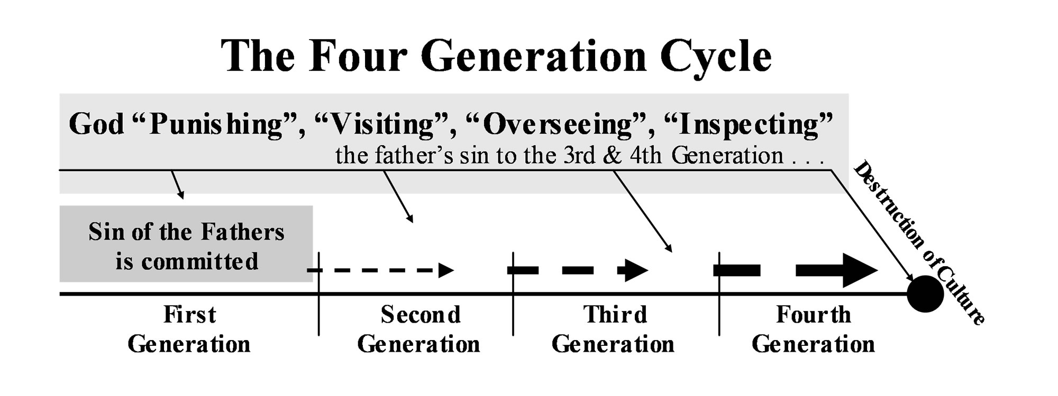

Our first example of this is spoken to Abraham around 2000 BC shortly after the tower of Babel and the institution of nations. It involves the land of Canaan between 1800-1400 BC. God is speaking to Abraham in Genesis 15. God’s covenant with Abraham has just been confirmed with a covenant ceremony. God now speaks to Abraham:
- about the future of his family
- about the rest of his own years on earth
- about the time when Israel will posses the promised land that Abraham now is living in but only as a temporary resident.

“Then the Lord said to him, ‘Know for certain that your descendants will be strangers in a country not their own, and they will be enslaved and mistreated four hundred years. But I will punish the nation they serve as slaves, and afterward they will come out with great possessions. You, however, will go to your fathers in peace and be buried at a good old age. In the fourth generation your descendants will come back here, for the sin of the Amorites has not yet reached its full measure.’” (Genesis 15:13-16)
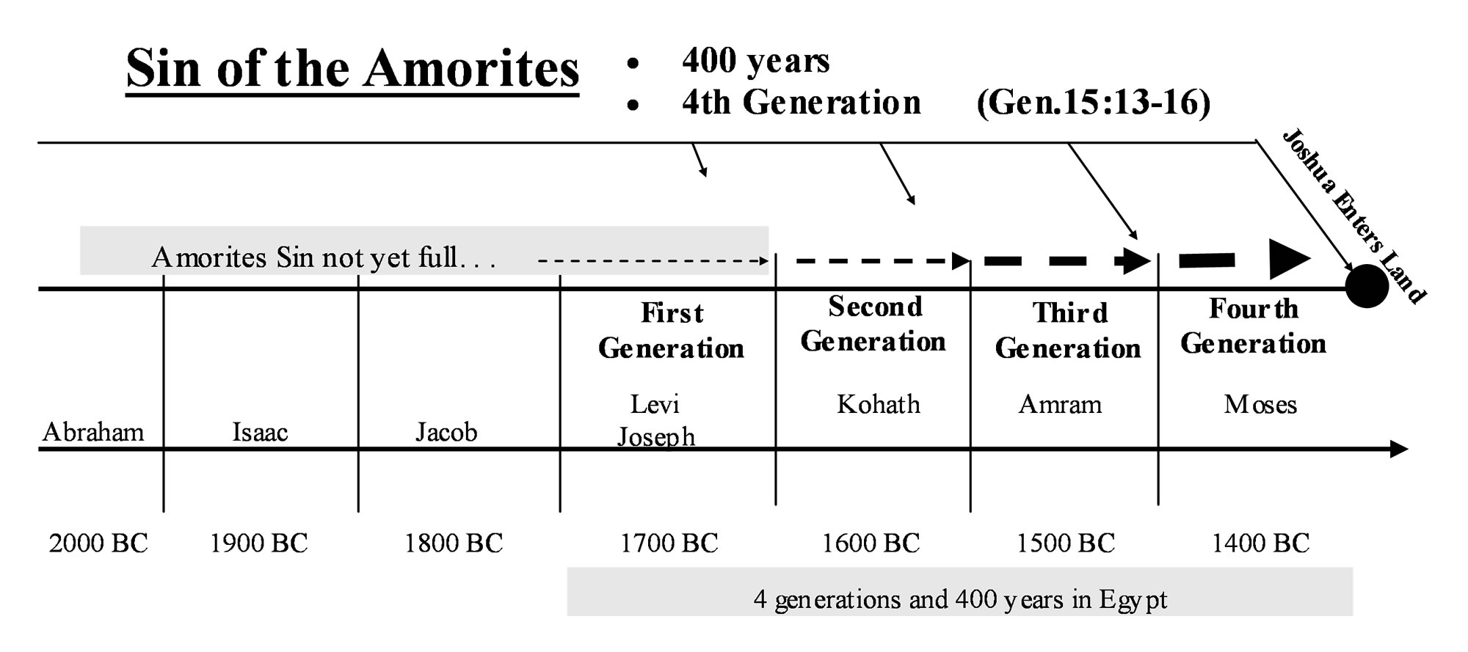
Abraham was told this prophecy around 2000 BC. He lived among the Amorites and entered into covenants with men like Mamre, Eshcol and Aner who were Amorite believers. (Genesis 14:13). The King of Salem (the ancient city of Jersalem /jer-salem/) was Melchizek who was also a believer and mature enough in his faith to minister to Abraham and serve as the priest of God Most High in his city (Genesis 14:18). Shem, one of Noah’s own sons was still alive and may have settled in the land of Canaan before Abraham arrived. During Abraham’s lifetime there were many believers and they were living and ministering among the Amorites in Canaan.
Noah’s Son Shem and Abraham

“Two years after the flood, when Shem was 100 years old, he became the father of Arphaxad. And after he became the father of Arphaxad, Shem lived 500 years and had other sons and daughters.”
Genesis 11:10

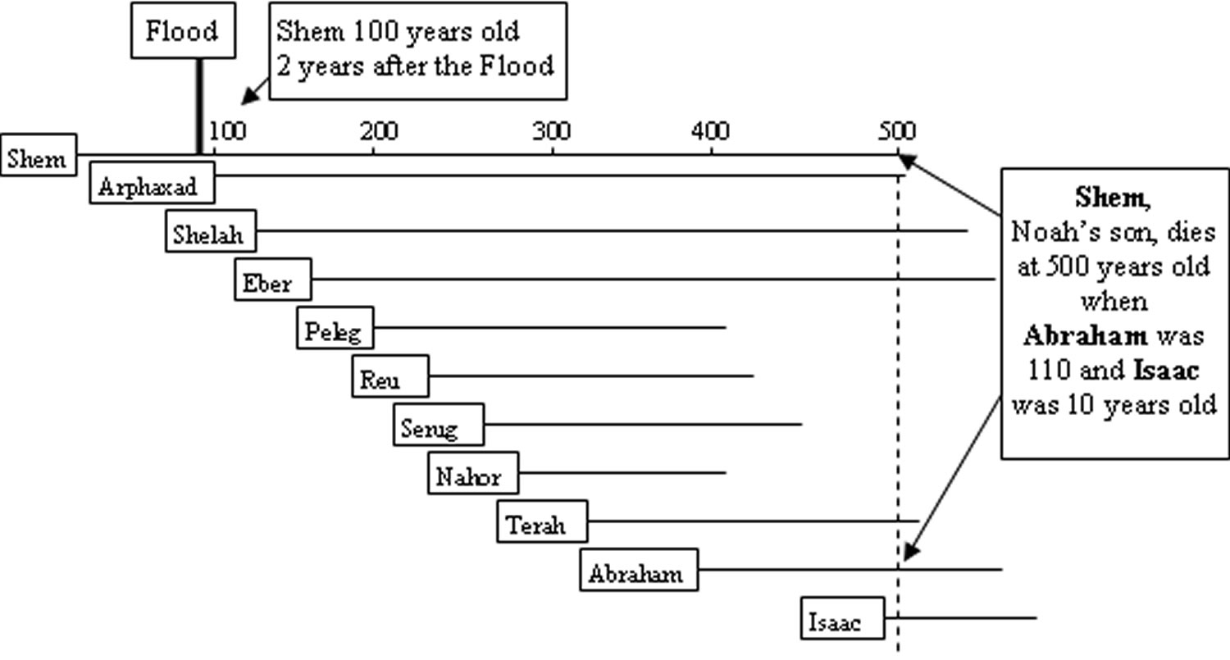

Note: Shem lived until Isaac’s generation. There would have been a first hand account of the entire flood story for 10 generations after the flood. Noah himself was the tenth generation from Adam.

After Abraham, Isaac and Jacob lived in the land of Canaan. Jacob had 12 sons and it was during their lifetime that Abraham’s family entered into Egypt and the four generation decline began in Canaan. Joseph was sold as a slave into Egypt first. During this first generation a famine was sent on the land of Canaan and the old man Jacob and his 12 sons and their families moved to Egypt. They would be there during the four declining generations of Canaan. After four generations Moses would lead Israel to the borders of Canaan and Joshua would lead them into the land to conqueror the Amorites. By the end of that fourth generation the entire land of Canaan had reached the fourth and final generation. As the second commandment says, God had observed their sin into the third and fourth generation. There would not be a fifth generation of this Canaanite culture. At the end of the fourth generation it took only five years of war for Joshua and the Israelites to conqueror the land, eliminate the Canaanite culture, and occupy the land of Canaan.

(This is something I would like to have in the back of the book in an appendix )

Humanist Manifesto I
(Humanist Manifesto I first appeared in The New Humanist, May/June 1933 (Vol. VI, No. 3)

“The time has come for widespread recognition of the radical changes in religious beliefs throughout the modern world. The time is past for mere revision of traditional attitudes. Science and economic change have disrupted the old beliefs. Religions the world over are under the necessity of coming to terms with new conditions created by a vastly increased knowledge and experience. In every field of human activity, the vital movement is now in the direction of a candid and explicit humanism. In order that religious humanism may be better understood we, the undersigned, desire to make certain affirmations which we believe the facts of our contemporary life demonstrate.

There is great danger of a final, and we believe fatal, identification of the word religion with doctrines and methods which have lost their significance and which are powerless to solve the problem of human living in the Twentieth Century. Religions have always been means for realizing the highest values of life. Their end has been accomplished through the interpretation of the total environing situation (theology or world view), the sense of values resulting therefrom (goal or ideal), and the technique (cult), established for realizing the satisfactory life. A change in any of these factors results in alteration of the outward forms of religion. This fact explains the changefulness of religions through the centuries. But through all changes religion itself remains constant in its quest for abiding values, an inseparable feature of human life.

Today man's larger understanding of the universe, his scientific achievements, and deeper appreciation of brotherhood, have created a situation which requires a new statement of the means and purposes of religion. Such a vital, fearless, and frank religion capable of furnishing adequate social goals and personal satisfactions may appear to many people as a complete break with the past. While this age does owe a vast debt to the traditional religions, it is none the less obvious that any religion that can hope to be a synthesizing and dynamic force for today must be shaped for the needs of this age. To establish such a religion is a major necessity of the present. It is a responsibility which rests upon this generation. We therefore affirm the following:

First: Religious humanists regard the universe as self-existing and not created.

Second: Humanism believes that man is a part of nature and that he has emerged as a result of a continuous process.

Third: Holding an organic view of life, humanists find that the traditional dualism of mind and body must be rejected.

Fourth: Humanism recognizes that man's religious culture and civilization, as clearly depicted by anthropology and history, are the product of a gradual development due to his interaction with his natural environment and with his social heritage. The individual born into a particular culture is largely molded by that culture.

Fifth: Humanism asserts that the nature of the universe depicted by modern science makes unacceptable any supernatural or cosmic guarantees of human values. Obviously humanism does not deny the possibility of realities as yet undiscovered, but it does insist that the way to determine the existence and value of any and all realities is by means of intelligent inquiry and by the assessment of their relations to human needs. Religion must formulate its hopes and plans in the light of the scientific spirit and method.

Sixth: We are convinced that the time has passed for theism, deism, modernism, and the several varieties of "new thought".

Seventh: Religion consists of those actions, purposes, and experiences which are humanly significant. Nothing human is alien to the religious. It includes labor, art, science, philosophy, love, friendship, recreation -- all that is in its degree expressive of intelligently satisfying human living. The distinction between the sacred and the secular can no longer be maintained.

Eight: Religious Humanism considers the complete realization of human personality to be the end of man's life and seeks its development and fulfillment in the here and now. This is the explanation of the humanist's social passion.

Ninth: In the place of the old attitudes involved in worship and prayer the humanist finds his religious emotions expressed in a heightened sense of personal life and in a cooperative effort to promote social well-being.

Tenth: It follows that there will be no uniquely religious emotions and attitudes of the kind hitherto associated with belief in the supernatural.

Eleventh: Man will learn to face the crises of life in terms of his knowledge of their naturalness and probability. Reasonable and manly attitudes will be fostered by education and supported by custom. We assume that humanism will take the path of social and mental hygiene and discourage sentimental and unreal hopes and wishful thinking.

Twelfth: Believing that religion must work increasingly for joy in living, religious humanists aim to foster the creative in man and to encourage achievements that add to the satisfactions of life.

Thirteenth: Religious humanism maintains that all associations and institutions exist for the fulfillment of human life. The intelligent evaluation, transformation, control, and direction of such associations and institutions with a view to the enhancement of human life is the purpose and program of humanism. Certainly religious institutions, their ritualistic forms, ecclesiastical methods, and communal activities must be reconstituted as rapidly as experience allows, in order to function effectively in the modern world.

Fourteenth: The humanists are firmly convinced that existing acquisitive and profit-motivated society has shown itself to be inadequate and that a radical change in methods, controls, and motives must be instituted. A socialized and cooperative economic order must be established to the end that the equitable distribution of the means of life be possible. The goal of humanism is a free and universal society in which people voluntarily and intelligently cooperate for the common good. Humanists demand a shared life in a shared world.

Fifteenth and last: We assert that humanism will: (a) affirm life rather than deny it; (b) seek to elicit the possibilities of life, not flee from them; and (c) endeavor to establish the conditions of a satisfactory life for all, not merely for the few. By this positive morale and intention humanism will be guided, and from this perspective and alignment the techniques and efforts of humanism will flow.

So stand the theses of religious humanism. Though we consider the religious forms and ideas of our fathers no longer adequate, the quest for the good life is still the central task for mankind. Man is at last becoming aware that he alone is responsible for the realization of the world of his dreams, that he has within himself the power for its achievement. He must set intelligence and will to the task.

34 Signers of the 1933 Humanist Manifesto I:

J. A. C. Fagginger Auer
E. Burdette Backus
Harry Elmer Barnes
L. M. Birkhead
Raymond B. Bragg
Edwin Arthur Burtt
Ernest Caldecott
A.J. Carlson
John Dewey
Albert C. Dieffenbach
John H. Dietrich
Bernard Fantus
William Floyd
F. H. Hankins
A. Eustace Haydon
Llewllyn Jones
Robert Morse Lovett
Harold P. Marley
R. Lester Mondale
Charles Francis Potter
John Herman Randall, Jr
Curtis W. Reese
Oliver L. Reiser
Roy Wood Sellars
Clinton Lee Scott
Maynard Shipley
W. Frank Swift
V. T. Thayer
Eldred C. Vanderlaan
Joseph Walker
Jacob J. Weinstein
Frank S. C. Wicks
David Rhys Williams
Edwin H. Wilson

