Churches Work Today

We are living in a time of great polarization. The dark is getting darker and the light is getting lighter. That is what this time and the years that will follow are all about. It is about time forcing us to make a decision. Many will continue in confusion because they refused the light. For those who accept the truth and reality of the scriptures the light is going to continue to shine brighter and brighter.

This is a time were people’s hearts are open and searching. The fourth generation is always a great time to be called to minister to a culture since there are so many things happening to assist a person testifying to the truth. I think of two biblical examples, one in the Old Testament and one in the New. Jonah was sent to the Assyrians just 40 days before their culture’s over throw. His message was simple but combined with all the events the Assyrians had seen and lived through it was powerful enough to cut right to their hearts. He had no music ministry that traveled with him. There was no sound crew or promotion team. He didn’t even have flyers or publications produced. All he had was a message and a culture that had been prepared by God with an eclipse, foreign invasion and plagues. Music and publications are nice but God’s didn’t need any of those in Ninevah in 759 BC. All Jonah had to do was go and proclaim the message he was given. His sermon is recorded in Jonah 3:4, maybe in its entirety:

“Forty more days and Nineveh will be overturned.”

There is no record of him beginning with the traditional opening line: “Repent!” I would guess, based on Jonah’s attitude, there was not a whole lot emotion wasted on his message either. The point is God is ready to reach our generation. We know we are living in the days of Laodicea. We realize people have been burnt out by secular humanism. We see the pattern of the fourth generation developing. And, we know it is through the members of the church that God is going to minister to this and any generation in the Church age. If you are a believer then you are a member of the church and one of the instruments God is using today. Jonah was trained in the school of the prophets but his message was simple and could have been proclaimed by anyone who understood the times.

In the New Testament Jesus spoke to the Samaritan woman at the well. After a conversation with Jesus by the well she ran back into the city of Sychar and simply testified about what she had heard Jesus say and then asked the people a question. She didn’t even make a proclamation or offer a Bible lesson or provide a great illustration. Her testimony and question simply struck a nerve of her city’s conscience. They heard her testify to what had happened to her and considered her hypothetical question. She said:

“Come, see a man who told me everything I ever did. Could this be the Christ?”
(John 4:29)

The result was similar to Nineveh’s response to Jonah. The city responds, many believe and Jesus spends the next two days teaching in Sychar. This occurred at the beginning of the fourth generation. It was easy for this woman to speak to her city because she was one of them. Jesus had sent his Jewish disciples into the city to “get food”. His intentions were that they would sense the spiritual opportunities in the city and open their “eyes and look at the fields! They are ripe for harvest.” (John 4:35) They returned to Jesus with sandwiches, but no “food”. Jesus then described for them what he meant by “food” when he said, “My food is to do the will of him who sent me and to finish his work.” (John 4:33) The disciples had failed in their ministry because they didn’t even recognize their ministry. As they munched on their sandwiches Jesus tried to explain to them their failure in the city due to their preoccupation with lunch. In comparison, the women instinctively knew what to do. She had already left her water pitcher and was heading back into the cit. A few moments later, even while Jesus was still explaining the situation to the disciples, she arrived with the people of Sychar who were coming to meet Jesus.

How hard can it be? We are at the right place in the right time. God is moving and people are searching. What is our number one problem? We are preoccupied with “lunch”. If we are going to see the fields that are ripe for harvest it will require that we be less absorbed in our own humanistic world and our Laodicean churches. If we will lift up our heads we will see not only the greatest field of opportunity in our time, but we will see that the greatest opportunity of the entire church age has been laid at the door of the church and Jesus is knocking. Who ever opens this door will see the fields are ripe for harvest again today.

Evangelism and change begin when people like the Samaritan woman have an encounter with Jesus and as a result are equipped to minister to their world. This is really what “going to church” is all about. Going to church is where the believer meets the Word of God and results follow. Ephesians 4:11, 12 tells us how people in the church age are equipped and how the body of Christ grows:

“It was he (Jesus) who gave some to be apostles, some to be prophets, some to be evangelists, and some to be pastors and teachers, to prepare God’s people for works of service so that the body of Christ may be built up.”

In the church God has provided people with foundational gifts – apostles, prophets, evangelists, pastors and teachers. These are not the pinnacle gifts or the peaks of ministry achievement. Nor are these the plush office jobs at the top of cooperate hierarchy of the church. (I know that here in the Laodicean church these are often six figure positions but I am talking about the biblical church and scriptural shepherds who are not coveting the sheep’s gold and clothes.) These gifts are the bottom, the beginning, the first steps of church ministry. It is through these gifts that God’s people are prepared for works of service. The apostle, prophet, evangelist, pastor and teacher are not doing the works that build the church, but instead, in their service to the church they are preparing God’s people for the works of service that will build the church. The church is built by the members of the church.

After one conversation with the Lord the Samaritan woman had been equipped to bring her whole city out to meet Jesus. Jesus didn’t go into the city, the woman went. When we stop seeing the pastor as the one who is in the ministry and we start associating ourselves with the ministry to our families, communities and nation the church will grow. Pastors are not the ones who build the body of Christ. Pastors are to prepare God’s people for the works of service that will build the church. And these works of service are not all done on Sunday mornings between 10:00 and 11:30 as ushers, greeters, parking lot attendants, nursery care, choir, counting the offering or running the information booth. Often you hear pastors encourage people to get involved in the ministry. They ask for ushers, baby sitters, or help in the parking lot. These are not the “works of service” Paul refers to in Ephesians 4. These are an extension of the foundational calling of the pastor/teacher. These would be extensions of the administration of the local church’s ministry of pastor. The works of service done by the people of God are outside the walls of the Sunday morning building. These works of service are done so the body of Christ may be built up. Where did Jesus tell his disciples he was going to be building the church? On the rock of pagan societies. On top of the Gates of Hades. If this is not being done it is not because the Gates of Hades has stopped it. It is most likely because both the people of God and their pastor think that ministry is done by ordained clergy to the laity in the church building or, if need be, in the hospital if a “lay” person lay sick. If this is the case, then what we have created is not a pastor or shepherd but a priest or a mediator to stand before the common man and their God. This is very, very pagan. The church has no priests, the church is a kingdom of priests:

“You are a chosen people, a royal priesthood, a holy nation, a people belong to God, that you may declare the praises of him.” (First Peter 2:9)

Pastors are to “prepare God’s people for works of service.” The pastor does not do the works of service for God’s people.

What Does a Good Pastor/Teacher Look Like?
A good pastor and the ministers in a local church should focus on making God real to the people who meet at the local church. These people, the people of God, should be the ones who take the reality and truth of God into their daily lives. The ministries of a church should be to heal the broken, refresh the weary (Rev. 3:15), and to “strengthen, encourage, and comfort” (1 Cor. 14:3) The pastor/teacher does not do the work of the ministry. The pastor/teacher prepares God’s people for the work of the ministry. A misconception is that the local church is the ministry. It is not. The work of the ministry occurs outside the local church. Pastors have a tendency to collect people. Not until the pastor, the teachers and the people of God realizes where they stand in the hierarchy of God’s plan are they able to fulfill their role.

A church should NOT look like this:
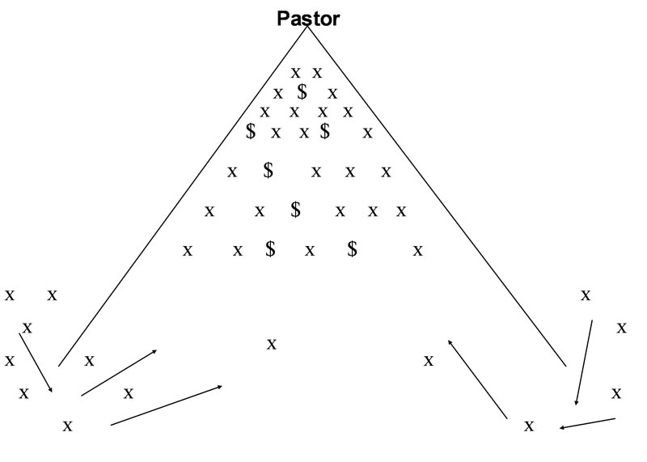
Here the pastor/teacher has the vision and believes the church is the ministry. The people are simply there to support the vision and ministry of the pastor/teacher. This is usually done by giving money and doing the things that need to be done for the pastor/teacher to be “effective.” Here the ministry or “works of service” are taken from the people and replaced with the vision of a man. It may be a good vision. It may include God’s plan for the pastor. But, it is still not the “works of service” that the people are to be prepared for. In this model the pastor is at the top and collects people.

A church should look like this:

Here pastors “prepare God’s people” (not the pastor’s people) for the gift and ministry God has called them. The people do the “work of the ministry” and build up the body of Christ. Here the pastor/teacher is the servant to those who do the ministry. People come to the local church for refreshing and healing. A healthy church will have people ministering at work, at home, and in their own “ministry” empowered by the Spirit. Teaching is not the pinnacle of ministry. It is foundational. A church that does not produce is underdeveloped.

Gideon and the Angel of the Lord Under the Oak Tree

In the book of Exodus the Lord came to Egypt to get Israel. With ten plagues and the parting of the Red Sea he brought his people to Mt. Sinai where he made a covenant with them. Forty years later he led them into the land of Canaan after he gave Joshua and them a command and a promise:

“Get ready to cross the Jordan River into the land I am about to give to them – the Israelites. I will give you every place where you set your foot, as I promised Moses. Your territory will extend from the desert to Lebanon, and from the great river, the Euphrates – all the Hittite country - to the Great Sea on the west. No one will be able to stand up against you all the days of your life.” (Joshua 1:3-5)

About four generation later in the days of Gideon the Israelites had forgotten the commands and promises of God. They mighty people of Israel who had swept through the land of Canaan in five years during the days of Joshua had now been reduced to hiding in shelters they had prepared for themselves in mountain clefts, caves and strongholds when the Midianites, Amalekites and other eastern peoples invaded their country. (Judges 6:2, 3) One day as Gideon was threshing wheat in a winepress to avoid being discovered by the Midianites the Angel of the LORD came and sat down under an oak tree and watched Gideon. The Angel of the LORD, who through out the Old Testament was a manifestation of the second member of the trinity or the Son of God, sat under a tree and watched a Gideon tried to separate the grain of the wheat in a valley instead of on a hill in the open breeze. Not only was Gideon trying to thresh in a valley with no wind but he was also hiding in a winepress which would be a large bathtub like vat. After watching this comic scene long enough the Angel of the LORD speaks to Gideon and says:

“The LORD is with you mighty warrior.” (Judges 6:12)
The LORD addressed this oppressed and cowering young man as a mighty warrior and told him the LORD was with him. This was not new information or the beginning of a new move of God. This was a reminder of where Gideon was at in time. The promises given to Israel in the days of Moses and Joshua had never been taken back of finished. The promises given 200 years before had simply been forgotten and set aside by the people of Israel. Gideon did not know why they were being overrun but he did remember the stories of the old days when God did move on Israel’s behalf and said back to the LORD:

“But sir, if the Lord is with us, why has all this happened to us? Where are all his wonders that our fathers told us about when they said, ‘Did not the LORD bring us up out of Egypt?’ But now the LORD has abandoned us and put us into the hand of Midian.” (Judges 6:13)

The theology of the days of Gideon taught that in their day “now the LORD has abandoned us.” There understanding was that the promises had been revoked, God’s plan had changed and they had been abandoned. The Lord replies to this misled theology and says:

“Go in the strength you have and save Israel out of Midian’s hand. Am I not sending you?”
(Judges 6:14)

The promises of God had not been revoked by God but forgotten by Israel. God’s plan had not been changed but had not been communicated to the succeeding generations. God had not abandoned his people, but instead they had abandoned God. The promise was still true, the plan had not changed nor had God left them. As in says in Hosea:

“My people are destroyed from lack of knowledge.” (Hosea 4:6)

The Angel of the Lord did not give Gideon a new promise. He did not anoint Gideon with oil or lay his hands on Gideon’s head for a special commission. There was no “move” of the Spirit but there was a reminder to “Go in the strength you have” and nothing more. The Angel of the Lord was sitting under a tree because his work had been done for generations. Anything that happened in Israel was now a matter of them remembering the commands and the promises and then acting on what God had told them to do. Everything else would fall into place.

The same is true for the church age. We were given promises and commands in the beginning of the church age. God’s plan for the church and the promises have not changed nor will they change until the church age is over. There is nothing new. There is no need for anything new because the original promises are good enough because the original purpose has not yet been fulfilled. Gideon was still in the age of Israel but wondering “Where are all his wonders that our fathers told us about.” So it is with our generation in the church age. God’s response to us would be the same as his response to Gideon, “Go in the strength you have.” There is nothing new nor is there anything missing. It is all here we simply need to use it.

If a contractor hires someone to build a house he also provides the plans for the house he wants built. Along with the plans is a material list indicating the type and quality of materials that are to be used. When God calls anyone to do anything he provides:
- The plans
- The materials

In the apostolic doctrine we find the plans and the materials that God will make available to those building the church through out the church age.

The Plan
The plan can be found in the scriptures. Jesus’ original introduction of the church age is in the kingdom parables in Matthew 13. The plan for us today is:

- communicating the Word of God to men
- realize there will be false teaching
- the church will grow from very small to very large
- the church will grow in every part of the world and at every level of society
- Israel would be set aside for a time while the whole world is secured.

In Matthew 16 Jesus says his plan is to build the church in pagan societies right over the top of their pagan philosophies even as the powers of Hades helplessly stand and watch. We also know from Matthew 16 and 1 Peter 2:4 that believers like “living stones are being built into a spiritual house” or spiritual temple “to be a holy priesthood” and offer our spiritual services to God for the continued growth and advancement of the church. Jesus tells us in Matthew 28:19 to “go and make disciples of all nations.” Paul tells Timothy that “God’s household, which is the church of the living God” is “the pillar and foundation of the truth” in the world during this present age. (1 Timothy 3:15) God’s plan for the last 2000 years is to build his church at every level of every culture as a pillar and foundation of truth for the world to see. “You are the salt of the earth” that will preserve societies from corruption, add flavor or meaning to life and prevent the false philosophies from growing in the hearts of man. (Matthew 5:13) “You are the light of the world” that they may find their way to the Father in heaven (Matthew 5:16)

The Building Materials

The building materials are people who receive the truth, accept Jesus payment for sins and are indwelt by the Holy Spirit.

“Now you are the body of Christ, and each one of you is a part of it.”
(1 Corinthians 12:27)

Jesus said at the Last Supper:

“I will ask the Father, and he will give you another Counselor to be with you forever – the Spirit of truth. The world cannot accept him because it neither sees him nor knows him. But you know him, for he lives with you and will be in you.” (John14:16, 17)

The person who believed in Jesus as the Christ would receive the Holy Spirit. This is something the average person in the world can not understand or experience. Jesus goes on to say that the Holy Spirit would also do these things for them:
- Teach you (John 14:26)
- Remind you of what Jesus said (John 14:26)
- Testify about Jesus (John 15:26)
- Guide you and Empower you to understand the word of God (John 16:13)

Paul tells the Corinthians:

“Now to each one the manifestation of the Spirit is given for the common good.”
(First Corinthians 12:7)

Believers indwelt by the Holy Spirit are the living stones (1 Peter 2:5) that serve as the building materials for God’s church. Each person in the church has the Spirit of God who will manifest or show himself in their lives for the common good of the church itself. These manifestations of the Spirit of God are called gifts of the Spirit. They are not natural talents like intelligence, industrial skills, musical ability, or anything you received when you were born the first time of natural parents. Spiritual gifts which manifest in believers are supernatural spiritual abilities that were given to you at you second birth or at the time you were born again when you accepted Jesus Christ. Just like your natural talents come from your natural parents, you spiritual gifts come from your spiritual Father. Indeed, after you are saved your natural talents and skills by be sanctified and you may use them in the church or for righteous endeavors but they are just that – natural abilities used by a child of God to bring glory to God. Do not sell yourself short and call your natural talents spiritual gifts. Your spiritual gift may manifest in a natural talent but still, your natural talent is not a spiritual gift.

The Gifts of the Spirit in the People of God
“There are different kinds of gifts, but the same Spirit. There are different kinds of service, but the same Lord. There are different kinds of working, but the same God works all of them in all men. Now to each one the manifestation of the Spirit is given for the common good.”
(1 Corinthians 12:4 )
From this verse we see these points of doctrine concerning spiritual gifts:
1. Divine Origin of the Gifts
a. The gifts are not natural talents
b. The gifts are from God as the Spirit, the Son and the Father work together through the believer.
2. Diversity of Gifts
a. There are different gifts which means the Spirit gives a variety of gifts to the people
b. There are different services which means Jesus has a variety of places and ways he
wants to use the selection of gifts that the Spirit has empowered.
c. There are different workings which means God the Father produces a wide variety of results from the Spirit’s gifts and the Lord’s use of those gifts.
The combination of different gifts with different types of service which God uses to produce a variety of results means the spiritual gifts are very unique in themselves. This is especially true when they are combined with the natural talents and personalities of the people that manifest them. A listing of the manifestations of the gifts, if it were possible, would look like a rainbow of color as one shade gradually moves into another shade. It is safe to say that as the variety of gifts manifest and produce through each person they are as unique as that person’s finger print. Point of application: Learn from others with similar gifts but do not lower yourself to mere imitation. Plan on being unique and get used to it.
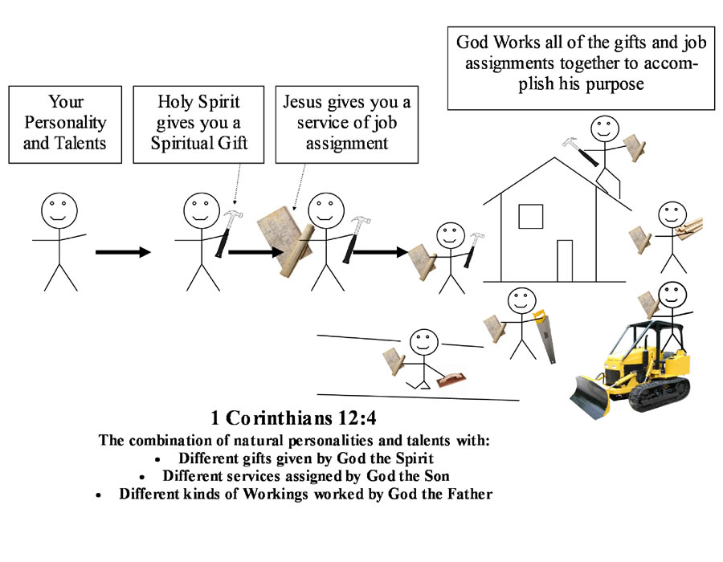

3. Purpose of Gifts
a. For the common good
b. 1 Cor. 14:3, to strengthen, encourage, comfort
c. 1 Cor. 14:12, to build up the church
d. Eph. 4:12, to prepare God’s people, to build the body of Christ
4. Grace of the Gift
a. Gifts are not earned by people
b. Gifts are not deserved
c. Gifts are distributed by the Spirit as He determines
d. 1 Cor. 12:11, “All these are the work of one and the same Spirit, and he gives them to each one, just as he determines.”
e. Romans 12:3, 6 “For by the grace given me I say to every one of you . . . we all have different gifts, according to the grace given us. . .
f. 1 Peter 4:10, “Each one should use whatever gift he has received to serve others, faithfully administering God’s grace in its various forms.”
g. 2 Corinthians 9:8, “God is able to make all grace abound to you, so that in all things at all times, having al that you need, you will abound in every good work.”
5. Distribution of the Gifts
a. Given to every one
b. Each person has a place in the body for each person is a part of the body
c. 1 Corinthians 12:12
6. Time of Receiving Gift
a. At the point of the new birth.
7. Development of the Gift
a. 1 Tim.4:14,15, “Do not neglect your gift, . . .”
b. 2 Tim. 1:6, “I remind you to fan into flame the gift of God. . .”
Each person has a gift, but that gift must be developed. If the gifts are given at the point of the new birth that means ever since you were saved you have had your spiritual gift. That gift needs to be discovered and developed. I discovered my gift of teaching in a fifth grade boys Sunday school classroom over twenty years ago, but I wasn’t ready to do anything but study during the week and practice my gift each week in the classroom. In fact, even today, every Bible study and sermon I preach I am developing and getting more familiar with the gift that I have had since I was 16 years old. Point of Application: Your gift is a grace gift from God, but you must be diligent to develop your gift. An undeveloped gift is useless and brings no production even though it was given to you by God.
8. Control of the Gift
a. 1 Cor.14:32, “The spirits of prophets are subject to the control of prophets.”
b. Each person is placed in control of their gift.
c. This is not demon possession where a person losses control of their will.
At no time is a spiritual gift “in charge” of the person who has received it. The gift can be turned on or turned off by the person using it. Yes, I know that statement will cause some to cry “heresy” if they haven’t already cried it a hundred times in this book. But think about it. If my spiritual gift is teaching do I wait for God to cause me to start teaching? Or do I send out a flyer and say starting at 7:30 on Monday night there will be a Bible study in my house? Do I put a little disclaimer at the bottom and say – “Warning: Spiritual gift of teaching may not be available that night. We must wait on God. . .” How about when I am preaching on a Sunday morning and I’ve been preaching for sixty minutes and I have a whole lot of information still rolling around in my head. I don’t want to quit but I am now getting out of line with the schedule of the church service to which people have come. My wife is giving me the “look” and the “cut it off signal”. I am under the influence of the spiritual gift and I can not quit? Or, can I turn it off on Sunday morning at 11:30 am just like I turned it on at Monday night Bible study at 7:30 pm. Spare me the accusations, but I turn it on and I turn it off. Sometimes it is easy and sometimes I can’t find the “on” switch, but if “the spirits of the prophets are subject to the control of the prophets” then “the spirits of the teachers are subject to the control of the teachers.”

List of the Gifts

Below is the gifts recorded by the apostles under the inspiration of the Holy Spirit. There is no indication that any of these lists are exhaustive since clearly they are not. There is no reason to think all of these gifts must be in operation through out the entire church age since, for example, the work of the apostles Paul and Peter are still the foundation of the church today. There is no reason to think that each generation will have an apostle to establish apostolic revelation since we have it recorded in the scripture. Likewise, there is no reason to start crossing gifts off the list because although you are a believer in Jesus Christ you rationalize from the viewpoint of a secular humanist and deny the supernatural. This list is not like programs offered at college. You do not get to pick your major. You either have the gift or you do not. Also, if you are in the “clergy” - just because you are licensed and ordained by men does not give you preferable selection opportunities of entire groups of gifts. You are human like the rest of us and so you are limited in your gifting and are forced to rely on those untrained “laymen” to provide the fullness of spiritual manifestation in your church. I suggest you identify your gifts and turn the rest of them back over to the flock. The main reason for the listing of the gifts is to help you identify what God the Spirit has already given you so you can develop it and perform the service that God the Son has assigned to you to so you can achieve the results that God the Father desires to work through the church his Son is building.

Romans 12:3-8
- Prophesying
- Serving
- Teaching
- Encouraging
- Contributing
- Leadership
- Mercy

1 Corinthians 12:8-10
- Message of Wisdom
- Message of Knowledge
- Faith
- Healing
- Miraculous Powers
- Prophecy
- Distinguishing between Spirits
- Tongues
- Interpretation of tongues

1 Corinthians 12:28-31
- Apostles
- Prophets
- Teachers
- Miracles
- Healings
- Administration
- Tongues

Ephesians 4:11
- Apostle
- Prophet
- Evangelist
- Pastor
- Teacher

1 Peter 4:8-11
- Hospitality
- Speaking
- Serving

